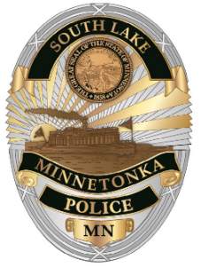
SOUTH LAKE MINNETONKA
POLICE DEPARTMENT
24150 SMITHTOWN ROAD
SHOREWOOD, MN 55331-8598
Brian Tholen
Chief of Police
Office (952) 474.3261
Fax (952) 474.4477

SOUTH LAKE MINNETONKA POLICE DEPARTMENT
COORDINATING COMMITTEE

Special Meeting – Chief hiring process

The Coordinating Committee for the South Lake Minnetonka Police Department will be holding a Special Meeting at 5:00 p.m. on Tuesday, March 4, 2025. The meeting will be at the South Lake Minnetonka Police Department – 24150 Smithtown Road in Shorewood.

Any questions should be directed to Chief Brian Tholen at 952.960.1601.

